**Media Streaming with IBM Cloud Video Streaming**

**Problem Statement Understanding**

**Problem:**

Develop a media streaming solution leveraging IBM Cloud Video Streaming services. The solution should enable seamless and reliable streaming of various media types (e.g., videos, live broadcasts) to end-users across different devices and platforms.

**Proposed Solution**

To address the problem of media streaming with IBM Cloud Video Streaming, we propose the following high-level solution design:

**1. Architecture Overview**

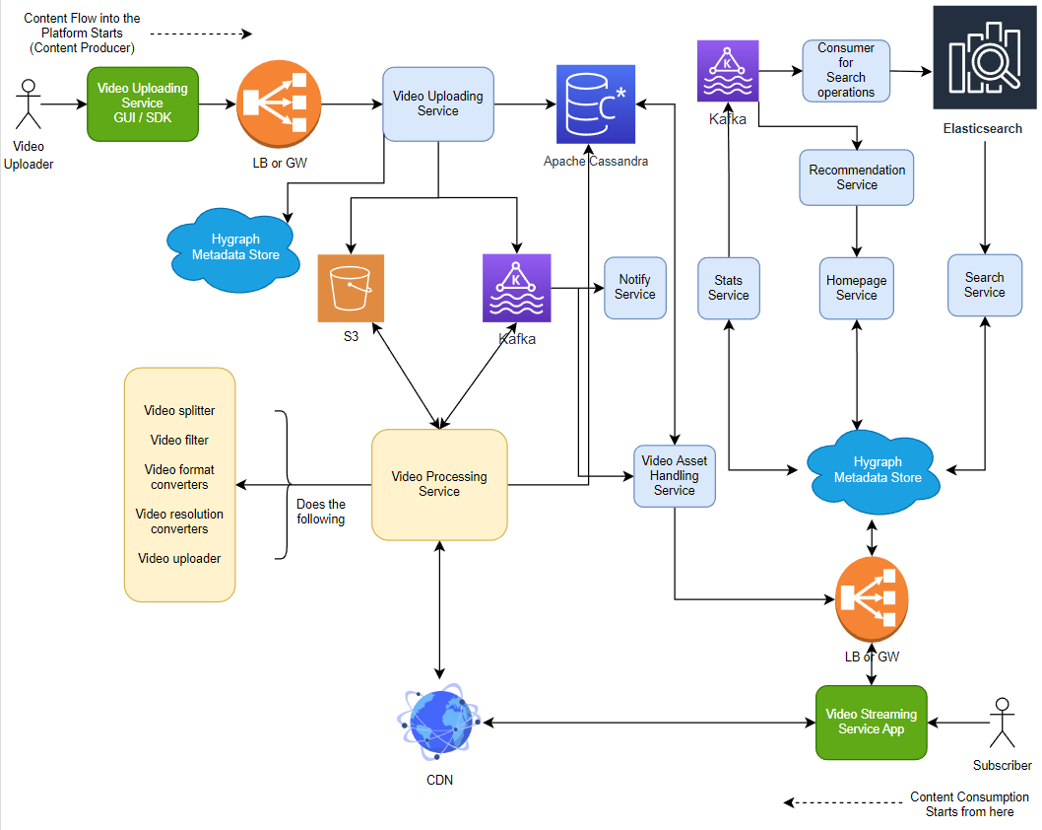

**Components:**

User Interface (UI): This component provides a user-friendly interface for content creators and viewers. Creators can manage their media content, while viewers can access and view the streams.

**Media Server:** The Media Server is responsible for encoding, transcoding, and storing media content. It leverages IBM Cloud Video Streaming services for efficient processing.

**Content Delivery Network (CDN):** CDN is used to distribute media content to end-users across the globe, ensuring low latency and high availability.

**Security Layer:** Implements authentication and authorization mechanisms to protect media content. Also, it includes measures to prevent unauthorized access and piracy.

**Analytics & Monitoring:** This component collects data on user interactions, stream performance, and content popularity for analysis and monitoring purposes.

**2. Implementation Steps**

To implement the proposed solution, follow these steps:

***Step 1:*** **Set up IBM Cloud Video Streaming**

Create an IBM Cloud account (if not already done). Provision and configure the IBM Cloud Video Streaming service. Obtain necessary API keys and credentials for integration.

***Step 2:*** **UI Development**

Develop a user-friendly web-based UI for content creators to upload and manage media content.

Create a user interface for viewers to browse and access streams.

***Step 3:*** **Media Server Implementation**

Implement the media server component responsible for media encoding, transcoding, and storage.

Ensure integration with IBM Cloud Video Streaming services for efficient processing.

***Step 4:*** **Security Integration**

Implement robust security measures, including authentication and authorization. Employ encryption techniques to protect media content during transmission and storage. Implement DRM (Digital Rights Management) for content protection.

***Step 5:*** **CDN Configuration**

Set up a Content Delivery Network (CDN) to distribute media content globally. Configure CDN to cache and deliver content efficiently.

***Step 6:*** **Scalability and Load Balancing**

Implement load balancing and auto-scaling to handle varying loads. Monitor system performance and scale resources as needed.

***Step 7:*** **Analytics and Monitoring**

Integrate analytics and monitoring tools to track user engagement, stream performance, and content popularity. Use the data collected for optimizations and improvements.

**3. Testing and Quality Assurance**

Conduct thorough testing to ensure the system's reliability, scalability, and security. Perform load testing to validate the system's ability to handle concurrent users and streams.

**4. Deployment and Maintenance**

Deploy the solution to production servers. Implement a maintenance plan for regular updates, security patches, and optimizations.